Windows 7
Initialization of Audit

Click Start => Control Panel. In the Control Panel window, double click Administrative Tools. In the newly opened Administrative Tools window, double click Local Security Policy.
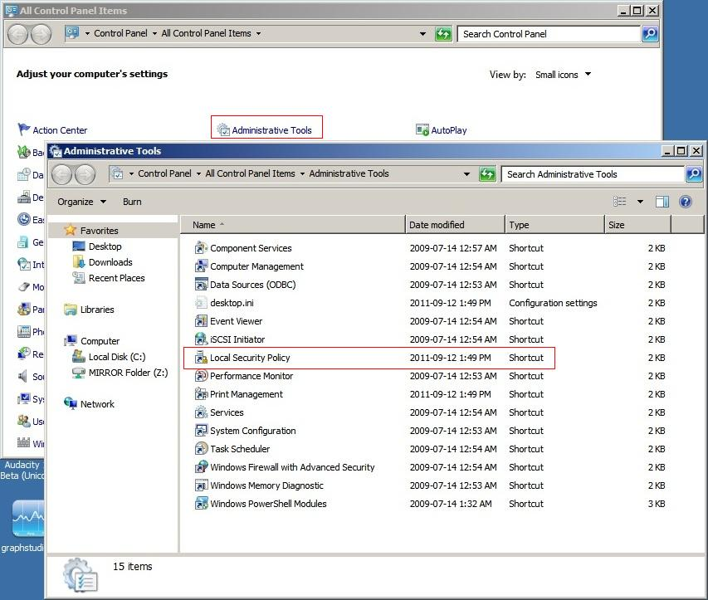

In the left pane, expand Local Policy by clicking on the + sign, and then on Audit Policy. In the right hand pane, double click on Audit Object Access.

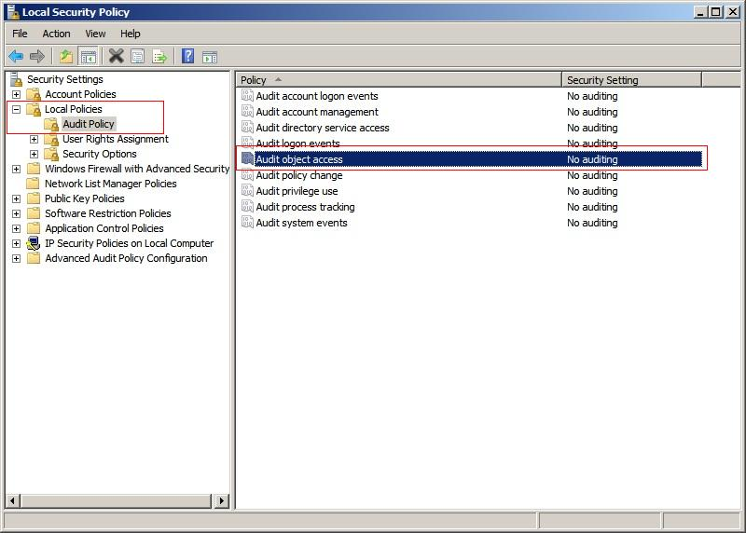

In Audit Object Access Properties, check both Success and Failure. Click OK to confirm selections.

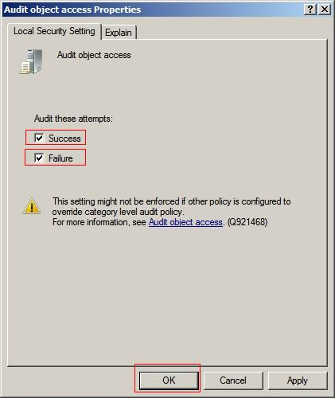

As shown below, the Local Policy Page should now reflect the previously configured settings. The Security Setting for Audit Object Access should now indicate Success and Failure.

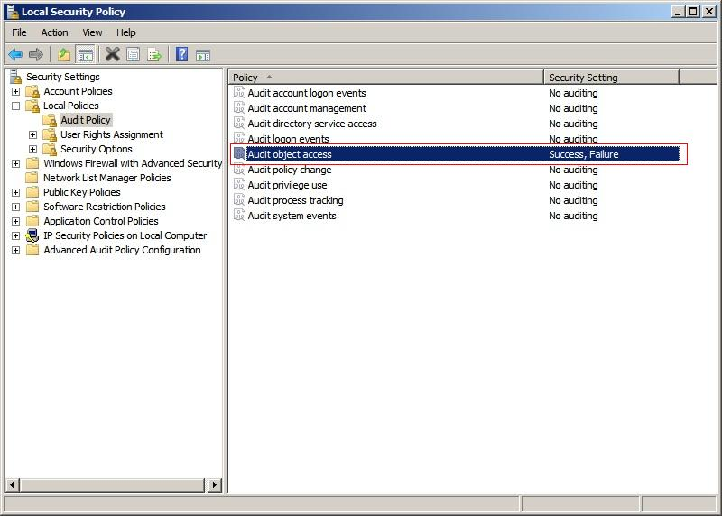

Setting the audit

Click Start => Control Panel. In Control Panel, double click Administrative Tools. In the Administrative tools window, double click Event Viewer.
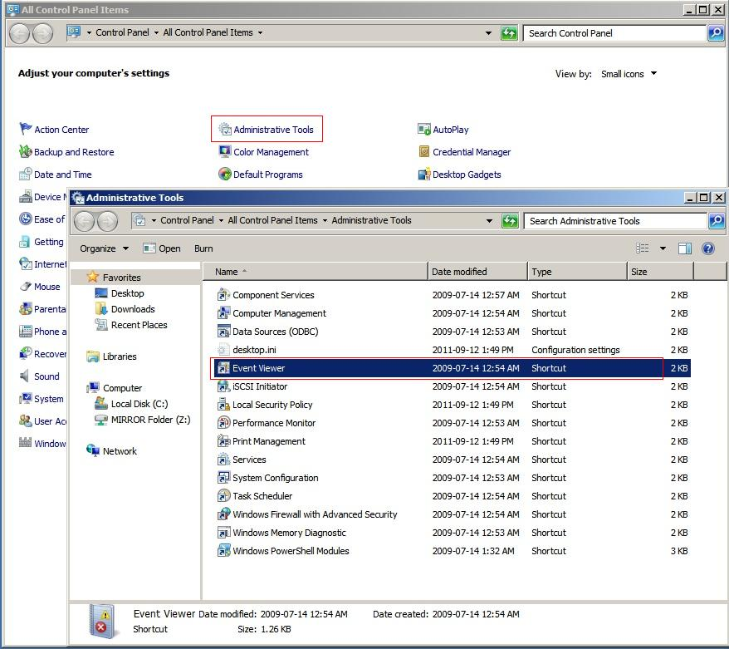

In the Event Viewer Window, click on the + sign to expand the Windows Logs folder. Then right click on Security and select Properties.

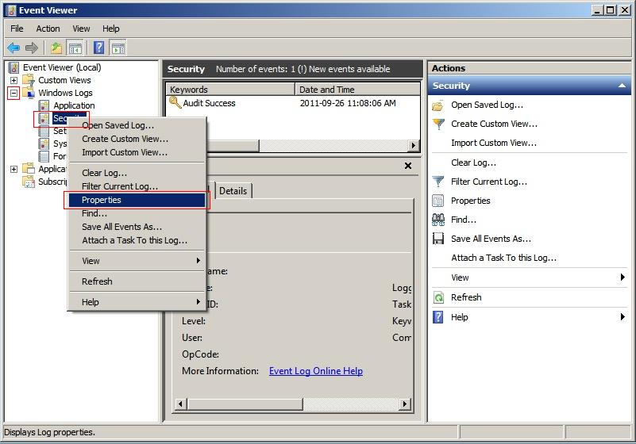

The Maximum Log Size and what to do when the maximum log size is reached should take into consideration how often the audit will be run and any IT policy that may be in place.
Note: Choosing a small log size along with Do not overwrite events may cause either audit information to be lost or the PC to become unusable until the even log is manually cleared.

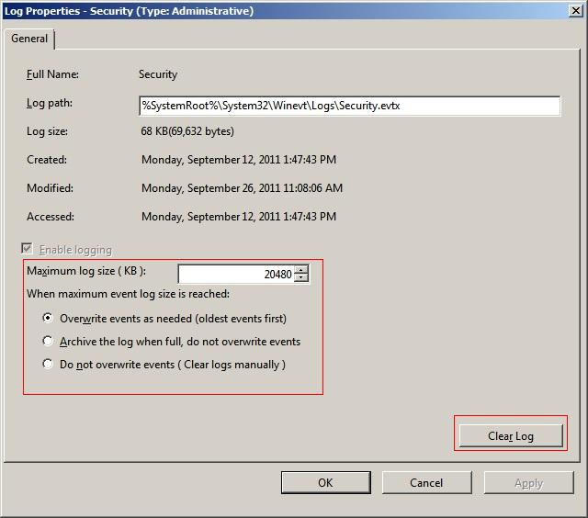

Adding Folders to the Audit
Use Windows Explorer to navigate to the desired folder. Right click on the folder and select Properties. On the Security Tab, click the Advanced button.

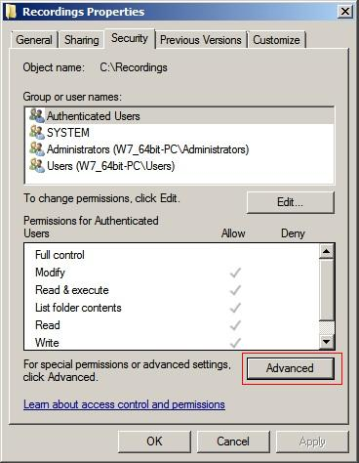

On the Advanced page, select the Auditing Tab and click on Edit.

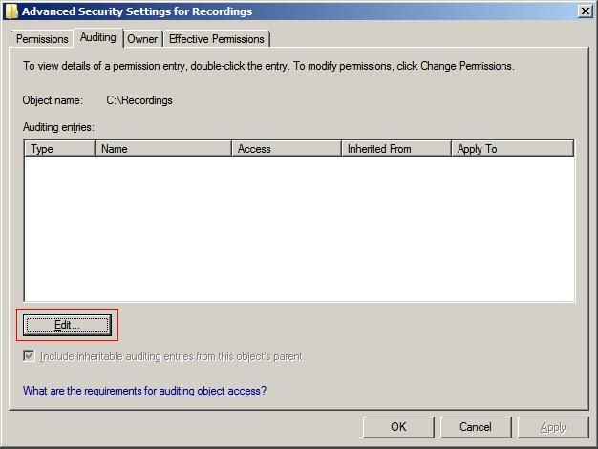

Click Add.
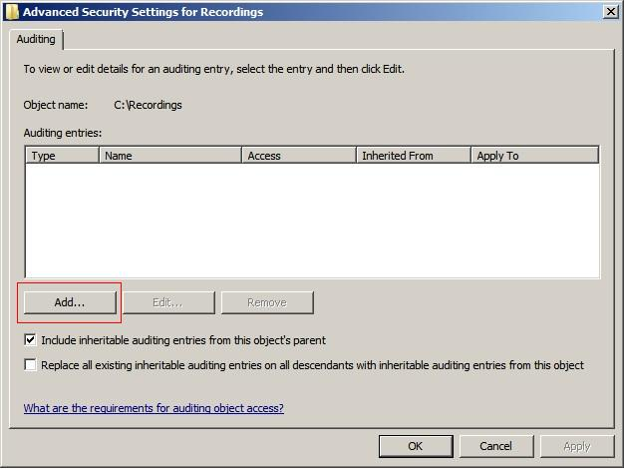

Click Advanced.
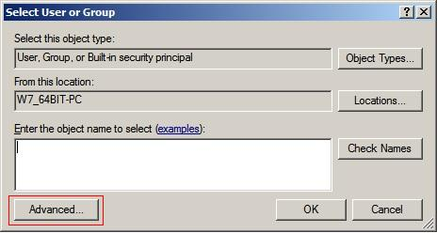
In the Select User or Group window, click Find Now.

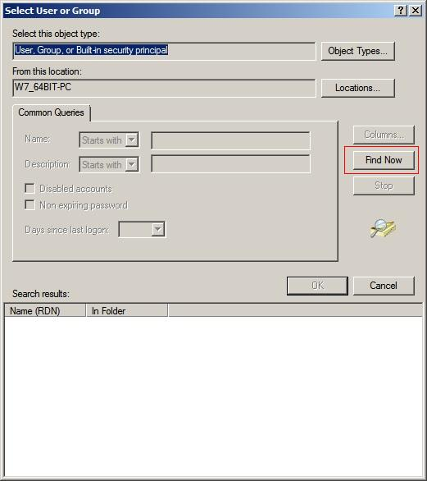

From the list in the search results window, select the desired User or Group (For example Everyone) and click OK.

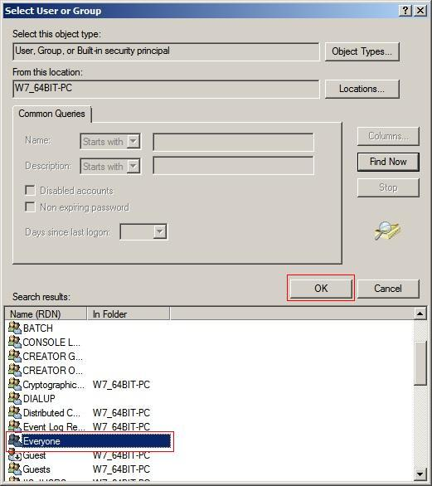

The selected object will be visible in the User or Group box. Click OK to confirm.
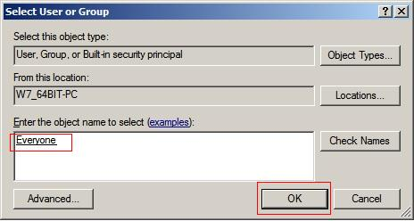
Place a checkmark in the Apply these auditing entries to objects within this container only box. Make sure that all the boxes under the Successful and Failed access fields are checked and then click OK.
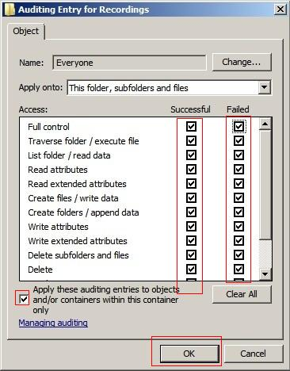
Click OK to confirm previous selections.

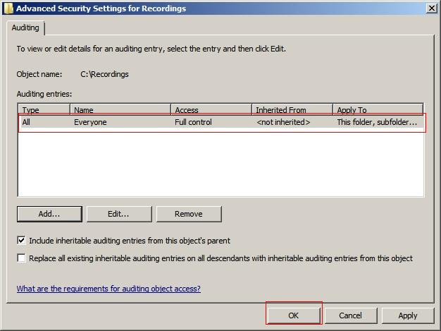

Once again, click OK
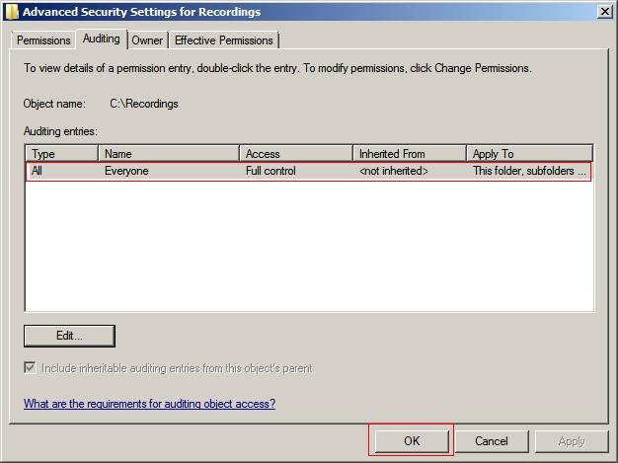

Finally, click OK to complete the folder audit setup.
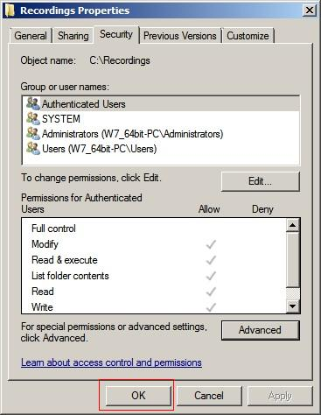
To include additional locations in the audit, repeat as necessary, the Adding Folders to the Audit section of this document.

